Kendriyavidyalaya Sangathan,

Summative Assessment 1

Subject: E V S Name : Time:2 hrs

Class : v sec: Roll :

|  |  |  |  |  |
| --- | --- | --- | --- | --- |
| COMPETENCY | OBSERVATION | IDENTIFICATION | DISOVERY OF FACTS | TOTAL |
| VALUE POINTS |  |  |  |  |
| GRADE |  |  |  |  |

Sign of invigilator sign of evaluator.

**Observation and reporting (20M)**

1.Observe the picture and answer the following questions

1. What is the name of the animal seen in the picture?

Ans:-____________ 

1. How many years does the animal live?

Ans:-____________

2. What do you observe in the given picture? Ans:-_______________ 

3. What do you observe in the glass jar?Ans: __________________



4. What do you observe in the picture given below?Ans:______________



5. What is this picture?Ans:_____________________



b. How do people get water from here?Ans:_________________

6. What is the man doing in the picture given?Ans:-_______________

7. What is given to the patient in the picture?

Ans:-______________ 

b. Why is it given to the patient?

Ans:-______________

**2. Answer the following questions.**1. Look at the water bill and answer the questions.

1. From which office has this bill come?

Ans:-_______________________

1. In whose name is the bill?

Ans:- _______________________

1. How much money do theyhave to pay for each month?

Ans:-________________________

1. Do you pay water bill and how much?Ans:-_______________________

2. What do you observe in the given picture and answer the following.

1. What is the name of the sea?

Ans:- __________________ 

1. Whyis the man floating in the water?

Ans:-

1. Observe the following picture and answer the following pictures
2. What is the name of the plant given in the picture?

Ans:-____________________ 

1. Where do you find this plant in India?

Ans:-___________________

1. What is the scientific name of this plant?

Ans:- ___________________

1. What does this plant eat?

Ans:-____________________

1. . Observe the picture and write for how many hours a day that animal sleeps

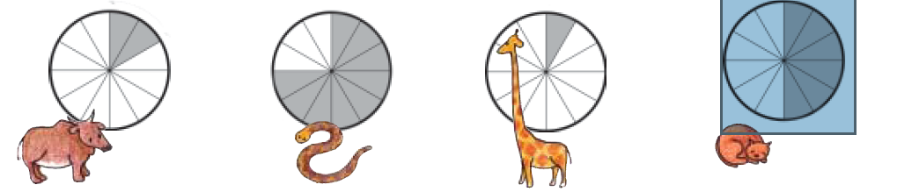

Cow__________ Python__________ Giraffe__________ Cat__________

**3. Look carefully at the map of Golconda and answer the following questions.**



1. If you are peeping inside from BodliDarwaza, in which

direction from you is KatoraHauz?

Ans:-_____________________

1. If someone is entering from BanjaraDarwaza, in which

direction from her is KatoraHauz?

Ans:-_____________________

1. In which direction will you walk from BalaHisar to reach

MotiMahal?

Ans:-_____________________

1. How many gates can you see on the outer walls of the fort?

Count how many palaces are there in the fort?

Ans:-_____________________

1. What arrangements for water can you see inside the fort?

Ans:-_____________________

**identification and Classification:-**

**Answer the following questions:-**

1. What are endangered animal?

Ans:-___________________

1. Who went on a yatra from Ahmadabad to Dandi and why?

Ans:-___________________

1. What is digestion?

Ans:___________________

1. What are the different ways of preserving food?

Ans:-__________________

1. Who are poachers?

Ans:-__________________

Answer the following questions:-

1. What are the food items that can be made using raw and ripe mangoes?

Ans:

1. What are the conditions a seed needs to germinate?

Ans:-

1. What is dispersal of seeds? What are the different ways of dispersal of seeds?

Ans:-

1. How many sense organs are there and what are they?

Ans:-

1. What kinds of tools are needed for climbing mountains?

Ans:-

Classify the following substances which will float and which will sink?

1. Leaf b. Keys c. Plastic ball d. Coin e. Oil f. Bottle with water

g. Paper h. Soap i. Bottle cap j. Soap with plastic tray

|  |  |
| --- | --- |
| Float | Sink |
|  |  |
|  |  |
|  |  |
|  |  |
|  |  |

**Discovering the facts**

Answer the following questions

1. Who is the first Indian women to reach the peak of mount Everest?

Ans:-______________________________________________

1. Why are bastions made in the fort wall?

Ans:- ______________________________________________

1. What are the colours in the National Flag?

Ans:-__________________________________________________

1. What is the green substance formed round the tabs?

Ans :- _________________________________________________

1. Why lizards are not seen in winter?

Ans :- _________________________________________________

II. Answer the following questions.

1. Draw the diagram of Seed Germination
2. Is there any monument in your city other than Golconda Fort? How old is it?

Ans:-

1. Who has discovered Malaria causing mosquitos and where?

Ans:-__________________________________________________

1. Differentiate the following substances which will dissolve and which do not dissolve?
   1. Salt b. Soil c. Chalk Powder d. Sugar

Ans :- _________________________________________________

1. How do snakes help farmers?

Ans :- _________________________________________________

Look at Arthi’s Blood report and answer the following questions:-

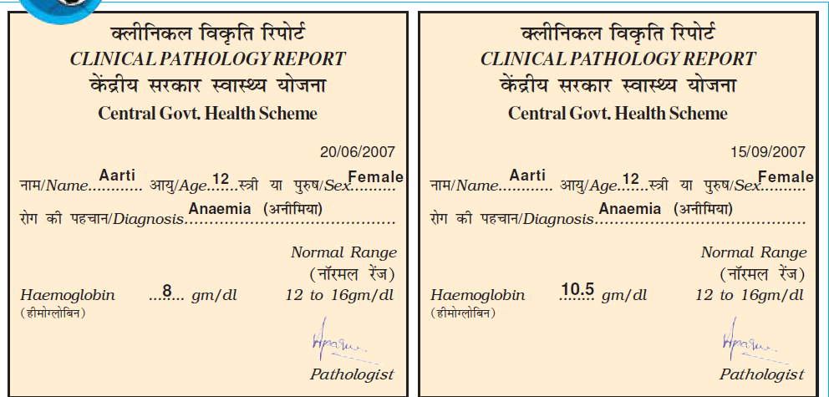

1. Look at Aarti’s blood report and find out the minimum

requiredhemoglobin?

Ans:-____________________

1. How much did Aarti'shaemoglobin go up?

Ans:-___________________

1. How longdid it take for the Haemoglob to increase?

Ans:-___________________

1. What was the diagnosis?

Ans:-___________________

1. How old is Arti ?

Ans:-___________________